OPTIC 2025, Two Page Manuscript Template
(Title should be centered 18 pt bold type, with Title Case
Formatting - Elements, and Acronyms Should Be Capitalized)

Author#1 name¹, Author#2 name^{1,2} [10-point type, centered, bolded]
1. Author affiliation and full address (8-point type, centered, italicized)
2. Author affiliation and full address (8-point type, centered, italicized)
Author e-mail address: (8-point type, centered, italicized)

Abstract: This electronic document is a “live” template. The various components of your paper [title, text, heads, etc.] are already defined on the style sheet, as illustrated by the portions given in this document. DO NOT USE SPECIAL CHARACTERS, SYMBOLS, OR MATH IN YOUR TITLE OR ABSTRACT. (Abstract for 100 words limited)
Keywords — component, formatting, style, styling, insert

- Introduction to the style guide, formatting of main text, and page layout
All manuscripts must be in English. These guidelines include complete descriptions of the fonts, spacing, and related information for producing your proceedings manuscripts. Please follow them and if you have any questions, direct them to the production editor in charge of your proceedings (see author-kit message for contact info).
The first line of the first paragraph of a section or subsection should start flush left without indentation. The first line of subsequent paragraphs within the section or subsection should be indented 0.62 cm (0.2 in.).
Paper size should be A4 format (210 mm x 297 mm). Margins should be set for a 2.5 cm top, bottom, left, and right. For text fonts: use only 10pt Times (roman, bold or italic), and Symbol. Page length should not exceed 2 pages.

- Figures and tables
Figures and tables should be centered (except for small figures less than 6.6 cm in width, which may be placed side by side) and located inside paper margins. Text should not wrap around figures or tables; table captions (10-point font) should be centered above tables, and figure captions (8-point font) should be centered below figures (for example, “Fig. 1 (a) Experimental Setup for UWOC and (b) schematic of the 450 nm laser diode-based UWOC system with a 12-meter underwater transmission path.”). Both should appear as close as possible to where they are mentioned in the main text. It is suggested that the resolution of graphic is 300dpi with all fonts embedded.
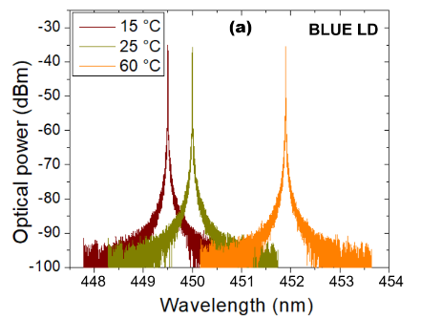
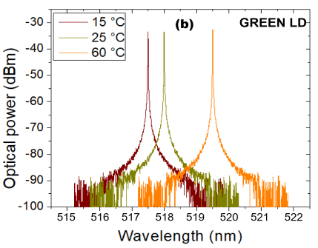

Fig. 1 The abbreviation “Fig.” (for figure) should appear first, followed by the figure number, a period, and then the figure caption.

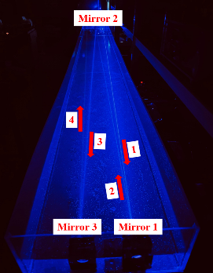
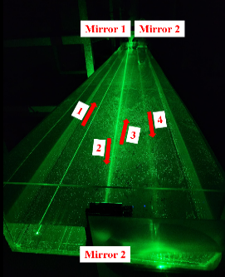
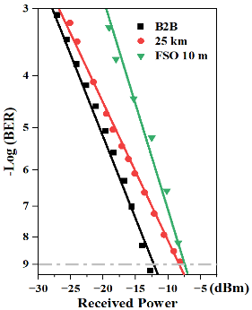
Fig. 2 The abbreviation “Fig.” (for figure) should appear first, followed by the figure number, a period, and then the figure caption.

- Equations
Equations should be centered, and equation numbers should only appear to the right of the last line of the equation, in parentheses. For long equations, the equation number may appear on the next line. For example:
$$\begin{aligned}C_{i,j,l}=\max{(\sum_{t=0}^{p-1}{X_{i,\left(l-1\right)p+t}K_{j,t}+b_{j,0})}. }\#\left(1\right)\end{aligned}$$
In-line math of simple fractions should use parentheses when necessary to avoid ambiguity—for example, to distinguish between 1/(n-1) and 1/n-1. Exceptions to this are the proper fractions, such as , which are better left in this form. Summations and integrals that appear within text such as $\frac{1}{2} \sum_{n=1}^{n=∞}{{\left(n^{2}-2n\right)}^{-1}}$ should have limits placed to the right of the symbol to reduce white space.
- References
References should appear at the end of the paper in the order in which they are referenced in the body of the paper. The font should be 8 point, and the references should be aligned left.
Within the main text, references should be designated by a number in brackets [1], and they should be followed by a comma or period [2]. Two references cited at once should be included together [3,4], separated by a comma, while three or more consecutive references should be indicated by the bounding numbers and a dash [1–7].

[1] R. F. Service, “Perovskite LEDs begin to shine,” Science 364, 918-920 (2019).
[2] Z. Wang, et al., “Single-Longitudinal Mode Ytterbium-Doped Fiber Laser Using Four 2 × 2 Fiber Couplers for Multiple Subring Ring Cavities,” IEEE J. Quantum Electron. 61-2, 1-6 (2025).
[3] D. F. Edwards, “Silicon (Si)” in Handbook of optical constants of solids, E. D. Palik, ed. (Academic, Orlando, Fla. 1985).
[4] F. Ladouceur and J. D. Love, “Silica-based buried channel waveguides and devices”, Chap. 80 (Chapman & Hall, 1995).
[5] A. Lee, B. Chang, C. D. Huang, et al., "Title of paper," in Title of Proceeding, Name(s), ed(s). Proc. SPIE 0, 00-00 (2018).
[6] E. Sun, F. Wu, and G. Kumar, "Title of paper," in Title of Proceeding, (Institute of Electrical and Electronics Engineers, New York, 2019), pp. 00-00.
[7] B. Pamukti, M.F.F. Pradipta, S. -K. Liaw, et al.,“Title of paper”, JOSA-B, 517639 (2024).

